Bacterial Growth and Induction of the Lac Operon in E. Coli

MMG Section 1

Devin Carree, Jerry Camacho, Hai Truong, Ali

September 15, 2019

**INTRODUCTION**

Bacteria being one of the earliest forms of life in our known universe can be very important to understand for understanding and furthering developments in science. Because all of life came from one common ancestor and bacteria emerged at a much earlier time than we did as human beings or eukaryotes in general, we can use its life as a model for the very primitive mechanism of growth and gene regulation that every organism that came after it must have used in order to survive, thrive, and evolve in its environment. This includes growth, replication, genetic transcription and translation and genetic regulation. Although eukaryotes and prokaryotes, has different mechanisms that they themselves specifically may expressed that other organisms do not, they also have a lot in common. Some observations that have made about genetic regulation include: Genes can be expressed differentially in response to different environmental signals, certain phenotypic expressions are coordinated with the growth of the organism and are independent of chemical influence, and the rate of elongation of DNA, RNA and proteins are independent of external factors (1). These facts are comparable to many genomes.

This experiment focuses on the exponential growth and induction of the Lac operon of bacterium *Escherichia coli. E. coli* and many other bacteria typically use glucose as its primary carbon-based source of energy, it also contains a set of inducible genes that code for proteins that are used to metabolize lactose while glucose is unavailable in the presence of Lactose. This set of genes are called the Lac operon. The Lac operon consists of three important genes, lacY which codes for a protein to make the cell permeable to lactose, lacZ which codes for β-galactosidase and lacI which codes for the repressor repressing the operon (2). β-galactosidase converts the sunusable lactose to both glucose and galactose, which can then be used by the cell as energy(3). This study observes the activity of the Lac operon in a lactose environment using ONPG as a substrate and IPTG as an inducer. The activity of three *E. coli* mutant strains were observed using inducer-rich and inducer-free environments. The three mutant strains included an lac+  lacI-, and lacZ-. Because the cleavage of ONPG produces a blue color, we use the color of bacterial colonies to represent the activity of β-galactosidase which in turn represents the activity of the operon, except where β-galactosidase is not present (lacZ- mutant). In the inducer-rich environment we expect to see blue colonies propagated from the lac+ and lacI- mutants and colorless colonies propagated from the lacZ- mutant. In the inducer-free environment we expect to see colorless colonies propagated from the lac+ and lacZ-mutants and blue colonies propagated from the lacI- mutant.

**MATERIAL AND METHODS**

In this experiment the experimental protocol for Bacterial Growth and Induction of Bacterial operons were followed (2). Except we determined the β-galactosidase assay reaction would occur for the same duration in each test tube.

**RESULTS**

The results that were obtained from the lab were the optical density of the culture as time increased and the amount of bacteria in the cell culture at the beginning of the experiment. Using the plated bacteria, the beginning amount of bacteria in the culture was calculated. The results of the optical density measurements are shown in table 1.

Table 1: This table shows the time that a bacterial culture has been growing and relates it to the optical density reported.

|  |  |  |  |  |  |  |
| --- | --- | --- | --- | --- | --- | --- |
| Time(mins) | 0 | 30 | 60 | 90 | 120 |  |
| OD625 | 0.197 | 0.352 | 0.572 | 0.759 | 1.089 |  |

The optical density vs time measurements correlate to the amount of bacteria present in the culture tubes (CFU/ml) in relation to time. As they each increased with increased time. The plated bacteria that we used to calculate the amount of bacteria present in the beginning of the culture are shown in figure 1.

1. A picture containing table

   Description automatically generated b. A picture containing indoor, table, plate

   Description automatically generated c. A picture containing table, indoor, cup, sitting

   Description automatically generated

Fig. 1: This figure shows the dilution of cfu in a bacterial stock culture. On the top row are bacteria grown for 90 mins, and from left to right diluted to a factor of 10-7. On the bottom row are bacteria grown for 120 mins, and from left to right diluted to a factor of 10-7.

The results of the β-galactosidase assay show that the bacterial mutants lac+

and lacI- created blue colonies in the IPTG-rich environment and the bacterial mutant lacZ­-­­ created colorless colonies. While in the IPTG-free environment the bacterial mutants lac+

and lacZ- created colorless colonies and lacI- created blue colonies. This is shown in figure 2.

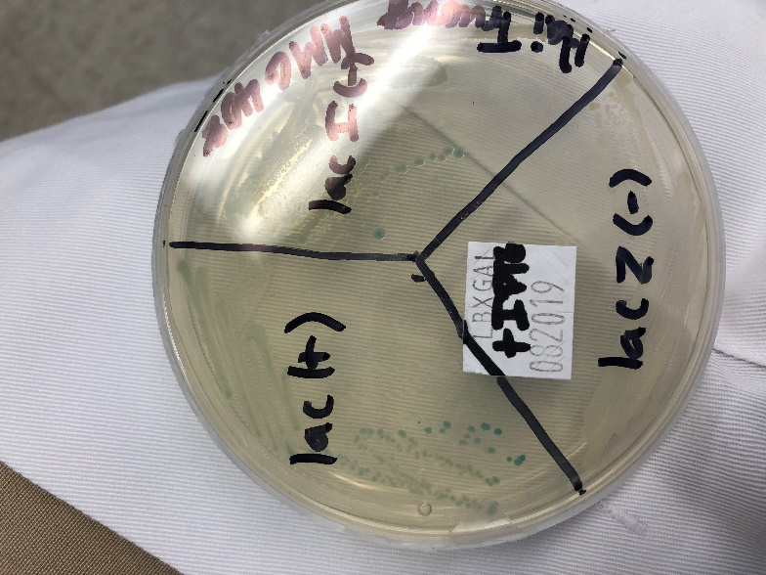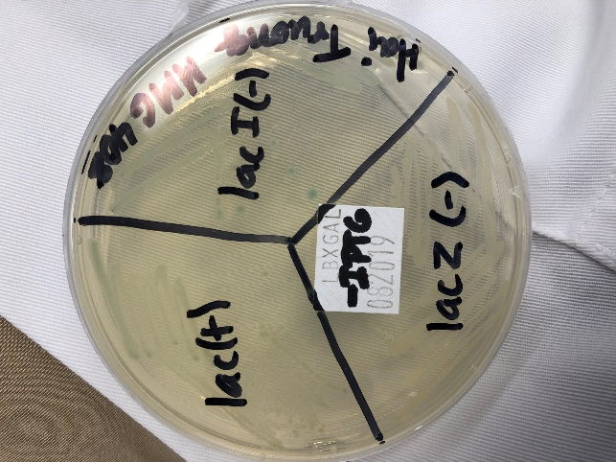

Figure 2: This figure shows 2 agar plates, one rich in IPTG inducer on the left and without IPTG inducer on the right. On each plate there are three strains of bacteria, lac+

lacI- and lacZ­-­.

Lastly we used our data to create a graph and extrapolate the relationship between the absorbance reading and the growth of our bacteria in our culture tube. This can be seen in figure 3. By extrapolation we determined that at an OD reading of 1 the number of bacteria that would have been grown in our cell would be 3.08 * 107

Figure 3 (see attached; on back to not waste paper): This figure shows a graph of the optical density vs time vs the cfu/ml. The optical density is shown on the y-axis on the right side while time is on the x-axis and cfu/ml is on the y-axis on the right side.

**DISCUSSION**

The results obtained match a lot of what is known already about bacteria. Bacteria is fast growing with a doubling time of about 60 minutes. This is an important fact when studying things such as mutations in bacterial models or evolution in some bacterial models. Another important idea that we have learned from this experiment is the induction of operons. This is important because it shows how genes and the genetic code work. Even in its very simplest form of *E. coli* the genetic code has many different functions and regulations that give the similar complexities as eukaryotes, which we can study and manipulate to best suit the needs of mankind. Through this experiment it was determined that reactions were catalyzed by specific proteins, using that information we can come up with different questions such as the mechanism of protein-membrane interaction of the permease protein or exclusivity of certain proteins in certain strains (3). The results of the experiment also matched up with the hypothesizes that were proposed at the beginning of the experiment. Because the protein is available when the operon is functional and able to be transcribed and unavailable when it isn’t it is easy to tell when the substrate will be cleaved.

**Bibliography**

1. Neidhardt FC. 1999. GUEST COMMENTARY Bacterial Growth: Constant Obsession with dN/dtJOURNAL OF BACTERIOLOGY.
2. Kashefi, K. 2019. MMG 408. EXPERIMENTS I – III: Experiment I: Bacterial Growth and Induction of Bacterial Operons, Bacterial Genetics Exponential Growth and Induction of the E. coli lac Operon
3. Yu Y, Tangney M, Aass HC, Mitchell WJ. 2007. Analysis of the mechanism and regulation of lactose transport and metabolism in Clostridium acetobutylicum ATCC 824. Appl Environ Microbiol 73:1842–1850.